1. Navigate to <https://servicecatalog.uhc.com>
2. Select Requests 🡪 Categories

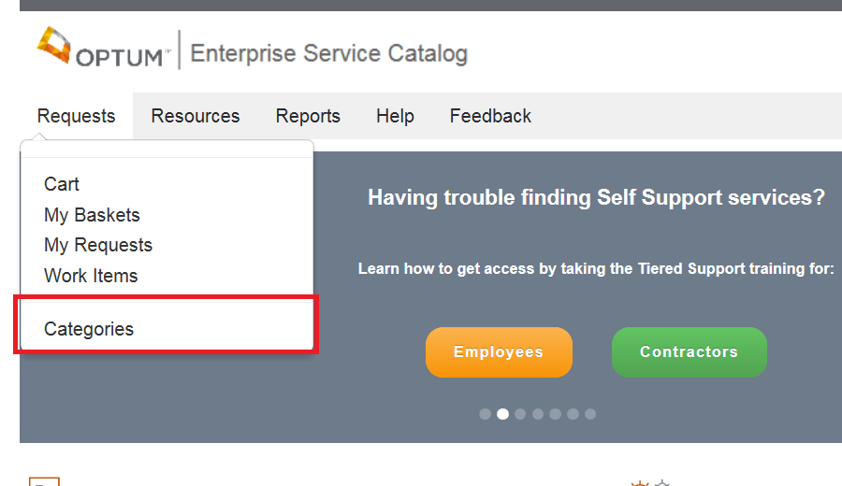

1. Select Infrastructure🡪 Application Development 🡪 Virtual Developer Desktops

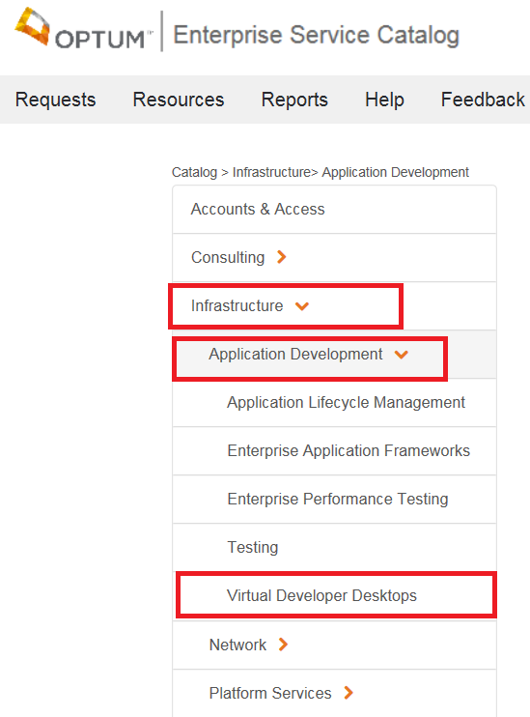

1. Click on ‘Select Request’ for Java Virtual Developer Desktop

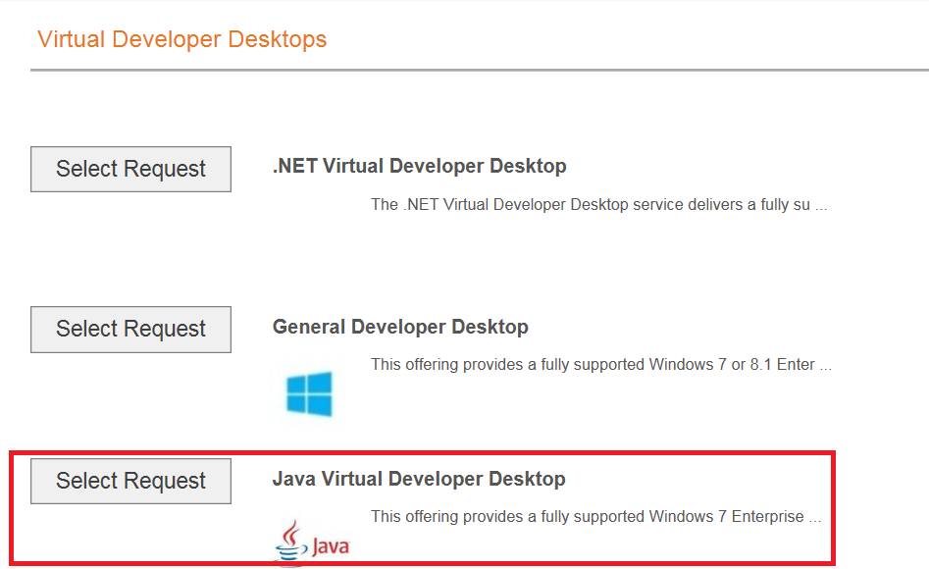

1. Leave ‘My Information’ section as it is
2. Select ‘Me’ from ‘Who This service is For’

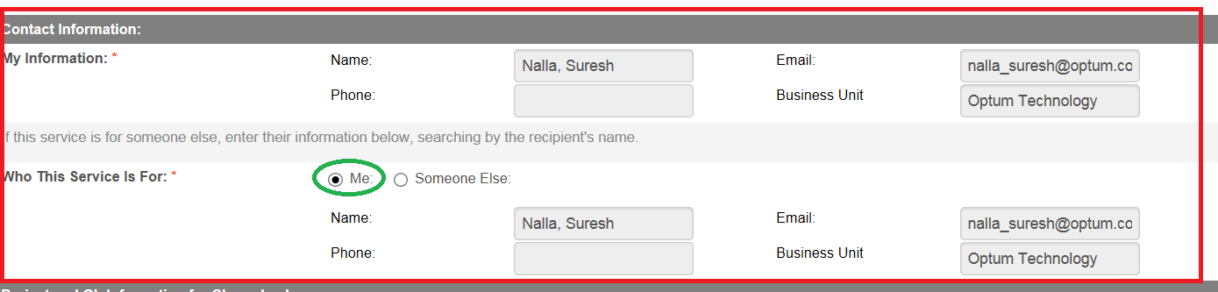

1. Select ‘No’ for ‘**This is for an Infrastructure Service Project:’**
2. Select ‘Mine’ from ‘Select GL to use’ section
3. Select ‘No’ for ‘Is This Related to Application’

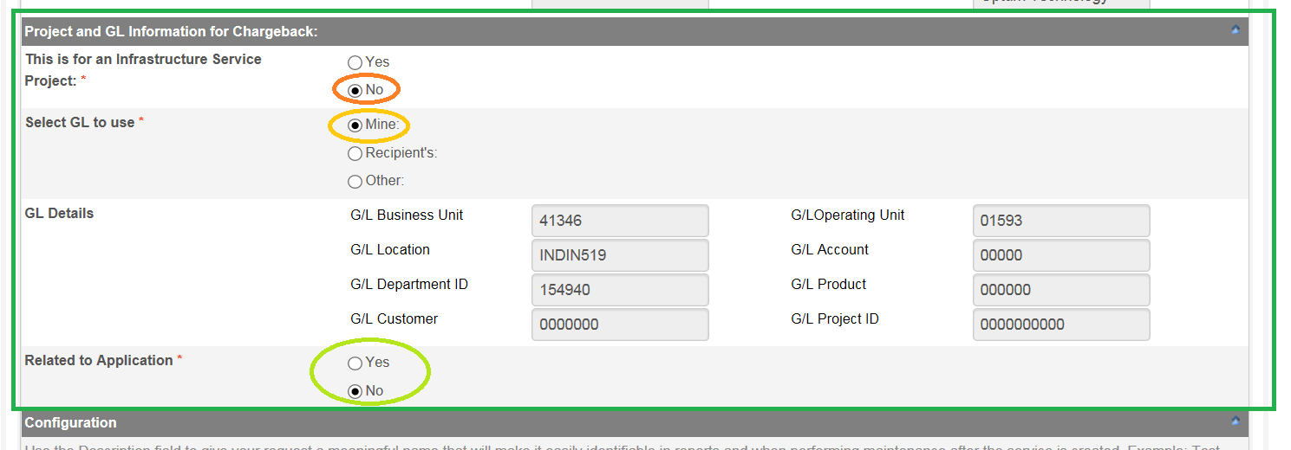

1. Enter Description – “Java Desktop for Automation’

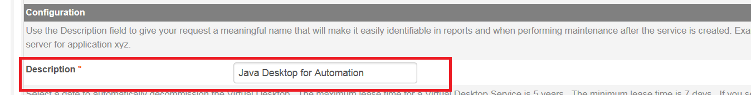

1. Select Decommission date - Any date up to 3 years from today as required
2. Usage Estimate – Low

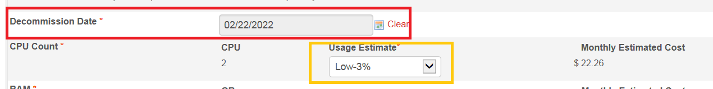

1. Select ‘External Access’ as ‘No’
2. Check ‘ I have read the above and Agree’
3. Click on ‘Add to Cart’
4. Click on ‘Submit Request’

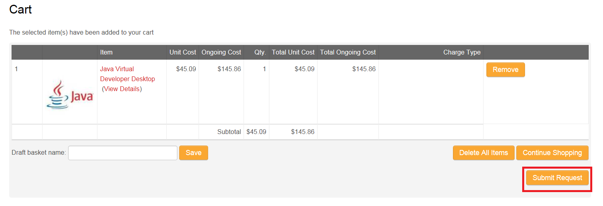

You will receive a mail with status as ‘In-process’ and ‘completed’ when the request is completed. Usually it takes less than a day for the request completion.

After you receive ‘Completed’ mail – in this mail you find a server name to use. It may be different for each person.

**VM Ware Horizon Client**

We need to connect to the Virtual machine using the server name. Below are the steps –

For that – we need to have ‘VM Ware Horizon client’ s/w to be installed in your local machine/Laptop.

Appstore Link - <http://appstore.uhc.com/AppInfo/AppVersionId/13894?BackToList=/AppList/AppList>

After installation of VM Ware Horizon client –

1. Open VM Ware Horizon client
2. Click on ‘New Server’

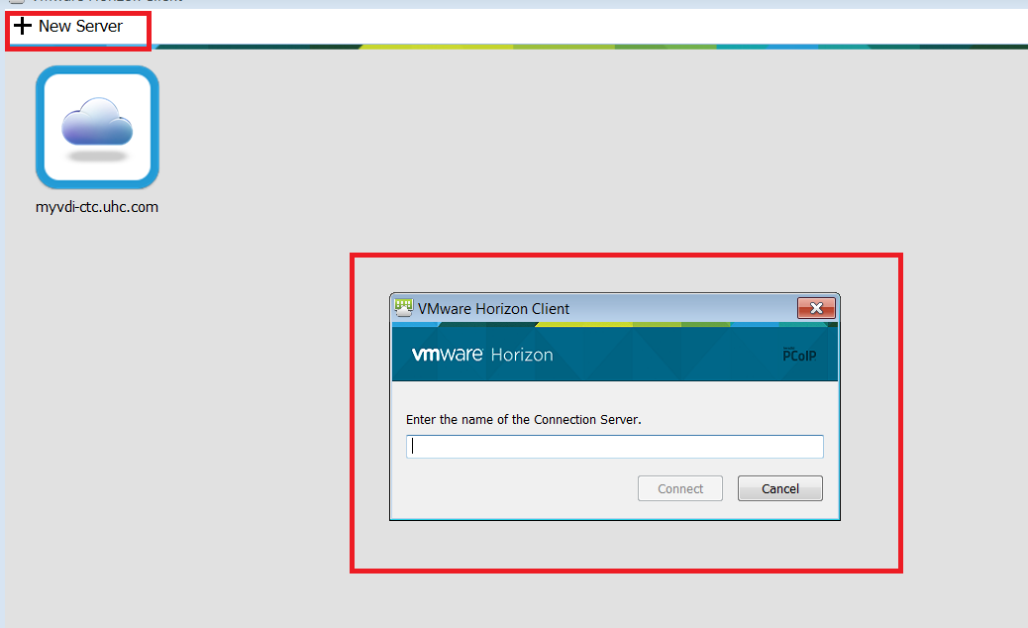

1. Enter the server name, which you received after raising the request in the above section and click on connect
2. Login with your MS credentials (without MS/)
3. Double click on ‘Java Virtual bDesktop’
4. You are now in VM
5. Raise all the required softwares in the machine using [www.appstore.uhc.com](http://www.appstore.uhc.com)